Number Systems

1. Fill out the complete table with the correct values.

|  |  |  |
| --- | --- | --- |
| Decimal | Binary | Hexadecimal |
|  | 100101110100101 |  |
| 852 |  |  |
|  |  | 0xD9 |
| 639 |  |  |
|  | 101110101 |  |
|  |  | E3h |

1. Now that you understand bits and bytes, you need to extend your knowledge of the binary numbering system to other things. As you will learn, everything about computer hardware relates to the binary numbering system. Answer the following questions about the binary numbering system and computer hardware. This relates to learning units one and two (1-point).
   1. How many bytes are there in a Kilobyte (KB)? (Exact value, not approximate.)
   2. How many bytes are there in a Megabyte (MB)? (Exact value, not approximate.)
   3. How many bytes are there in a Gigabyte (GB)? (Exact value, not approximate.)
   4. How many bytes are there in a Terabyte (TB)? (Exact value, not approximate.)
   5. What is the unit of measure for Random Access Memory?
   6. What is the unit of measure for a hard drive?
2. In your computer, open Windows Explorer, go to My Computer, and right-click on the C:\ drive and click on Properties.

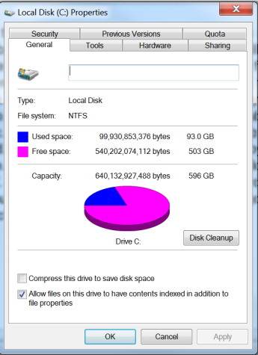

Explain how the value in bytes in the Used and Free space converted to the value in GB. Show that calculations.

1. Fill in the table below with the binary and decimal representations for the following ASCII characters.

|  |  |  |
| --- | --- | --- |
| ASCII Value | Binary Number | Decimal Number |
| F |  |  |
| ! |  |  |
| ( |  |  |
| 4 |  |  |
| w |  |  |

1. Convert the following decimal values to Hex.

|  |  |
| --- | --- |
| Decimal | Hex |
| 4875 |  |
| 1295 |  |
| 89 |  |
| 7829 |  |
| 985 |  |